**EXPERIMENT 1**

Introduction to Computer hardware: Physical identification of major components of a computer system such as mother board, RAM modules, daughter cards, bus slots, SMPS, internal storage devices, interfacing ports. Specifications of desktop and server class computers. Installation of common operating systems for desktop and server use. (Students may be asked to formulate specification for computer to be used as Desktop, Web server)

What is Computer?

A computer is a programmable electronic device that accepts raw data as input and processes it with a set of instructions (a program) to produce the result as output. It renders output just after performing mathematical and logical operations and can save the output for future use. It can process numerical as well as non-numerical calculations. The term "computer" is derived from the Latin word "computare" which means to calculate.

**The basic parts without which a computer cannot work are as follows:**

* **Processor:** It executes instructions from software and hardware.
* **Memory:** It is the primary memory for data transfer between the CPU and storage.
* **Motherboard:** It is the part that connects all other parts or components of a computer.
* **Storage Device:** It permanently stores the data, e.g., hard drive.
* **Input Device:** It allows you to communicate with the computer or to input data, e.g., a keyboard.
* **Output Device:** It enables you to see the output, e.g., monitor.

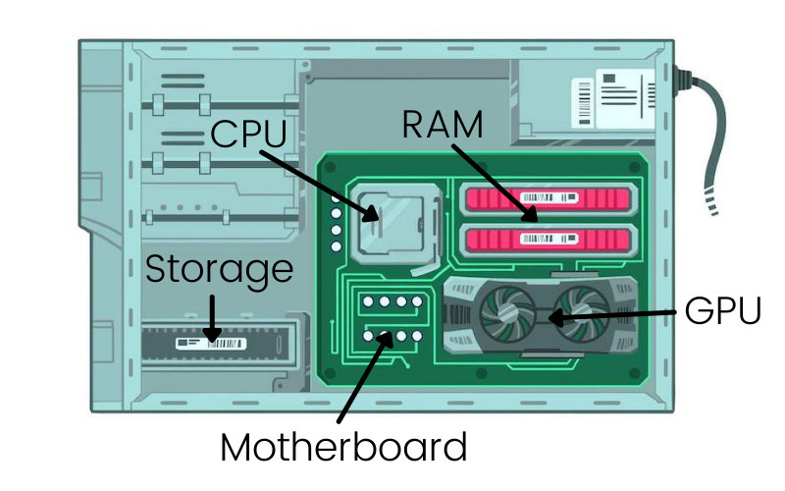

### **1 Motherboard**

The motherboard is defined as a circuit board for the computer system, also called logic board or mainboard. In the computer system, the biggest component is the motherboard that controls all the components of the computer system and establishes a link between all components. From the motherboard, different components like ROM, CPU, RAM, PCI slots, USB ports, and other components are connected. The controller’s device is also attached to the motherboard like DVD< hard drive, mouse, and keyboard. The computer system starts using the motherboard and these components act as the backbone for starting the system.

### Components of Motherboard

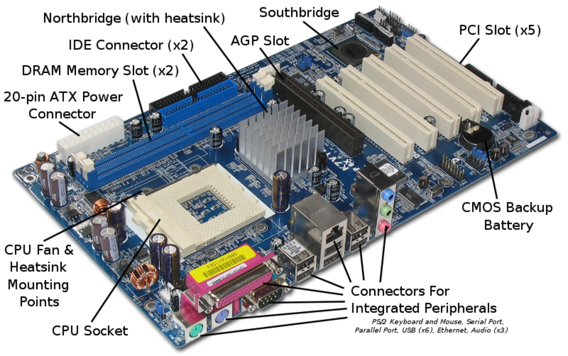

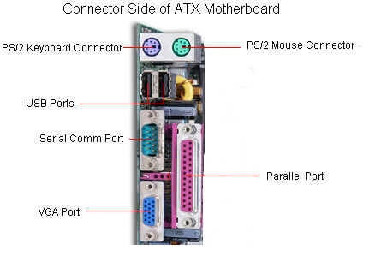

#### 1. Keyboard and mouse

There are mainly 2 types of mouse and keyboard connectors. The first connector is known as PS/2 & the second connector is known as USB.

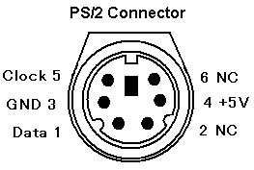

#### **2. Universal Serial Bus (USB)**

The USB port is used for connecting the computer system. In the computer system, there is various type of devices that are connected with the USB port like keyboard, mouse, camera, scanner, printers, and another device. The main use of a USB port is to connect the peripheral devices and computer motherboards. The peripheral device connected to the computer system can be inserted or remove without system restarts that can be the main advantage of a USB port.

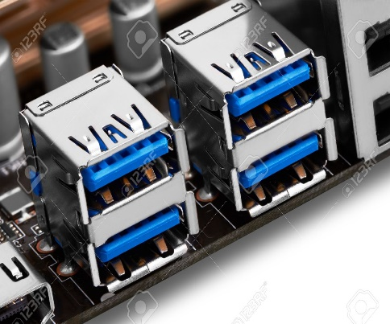

3. Parallel port

The old printers that are used in past use the parallel port to connect with the computer system. In the parallel port, multiple wires are used to send or receive multiple bits of the data in a single instance. On the other hand, serial ports use only one wire at a time.  In the parallel port, 25 pins female DB type connector is used.

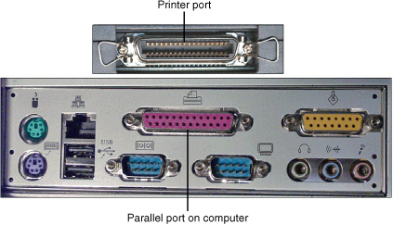

#### 4. CPU chip

The central processing unit is the processor that controls all the functions of the computer system. The overall flow of task and functions are controlled by the central processing unit. For the computer system, the central processing unit is called the brain of the computer system.

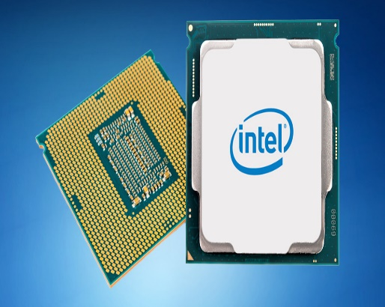

#### 5. RAM slots

The RAM slots are used for connecting the RAM (memory) in the computer system. In the general computer system, there are mainly two RAM slots but sometimes there can be four-plus slots in the motherboard to increase the memory of the computer system.

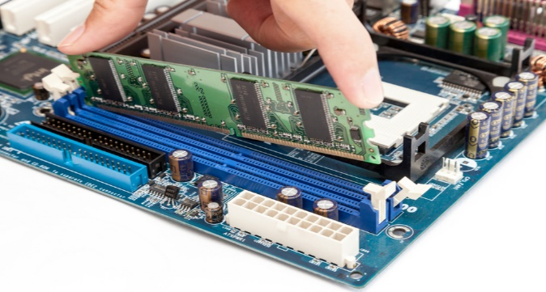

#### 6. Floppy Controller

The older motherboard chip contains a 34-pin type ribbon cable for connecting the computer system with a floppy drive. In this ribbon cable, one end is directly connected with the computer system and one end is connected with the motherboard.

#### 7. IDE controller

The integrated drive electronics are also known as ATA or Parallel ATA. The IDE is the type of component that issued for hard drive control. In today’s computer system, the IDE controller supports is not supported.

#### 8. PCI slot

The full form of PCI is a peripheral component interface. The PCI slot is mainly used to insert the expansion cards on the computer. The other PCI devices can also be connected like a sound card, network card, video, card, modems, and other device3s. In today’s computer system support for PCI expansion slots are not there.

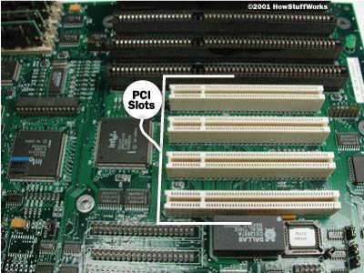

#### 9. ISA slot

Industry-standard architecture (ISA) is defined as standard architecture for expansion bus. The ISA slot issued for connecting input devices and modems.

#### 10. CMOS Battery

The CMOS battery is used for storing the BIOS settings on the motherboard. The CMOS battery is also capable of storing the time and data in it.

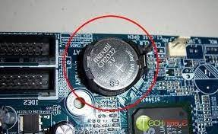

#### 11. AGP slot

AGP (Accelerated Graphics slot) is a type of computer slot that is used for attaching the video card to the system. This slot is a high-speed slot so that data transfer can be done at high speed.

#### 12. CPU slot

The CPU slot is a type of port that is used to connect the central processing unit to the motherboard of the computer system.

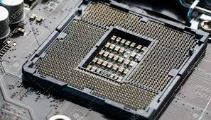

#### 13. Power supply slot

The power supply slot is used for providing the electric supply to the computer system so that it can start and perform its functions. The total power supply given to the system is around 110 ac power. In the power supply type connector, there are a total of 20-pins that are used to maintain the power supply to the computer system.

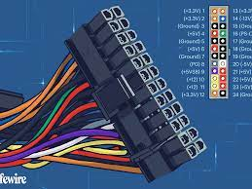 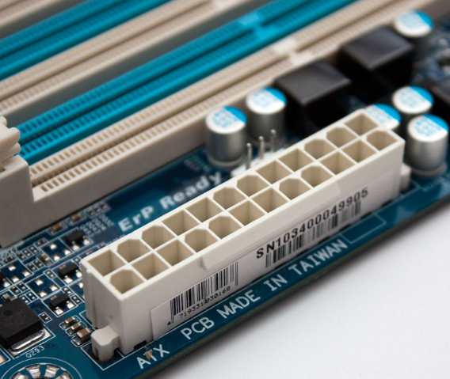

**The Mother Board May Be Characterized By The**

* Form Factor
* Chipset
* Type of processor socket used

**1.Form factor** refers to the motherboard’s geometry, dimensions, arrangement and electrical requirements. Advanced Technology Extended (ATX) is the most common design of motherboard for desktop computers.

#### 1. ATX

In this type, the standard locations were defined for mouse, keyboard, input/output devices, video connectors, and other devices. In the year 1990, the ATX form factor was developed. The expansion slot given new location as in this form factor expansion slot were given separate space so that they can be connected with the motherboard.

#### 2. Micro-ATX

The benefit obtained from the Micro-ATX is the same as from the ATX form factor. The main difference is an improvement in system design so that the overall cost of the component can be reduced as the size of the motherboard is reduced in this form factor. The size is reduced by reducing the I/O slots number on the motherboard.

**2. Chipset** is a circuit, which is used to controls the of resources such as the bus interface with the processor, cache memory and RAM, expansion cards, etc. It used to coordinate data transfers between the various components of the computer.

**3. The processor socket** is a connector into which the processor is mounted. The Basic Input Output System (BIOS) and Complementary Metal-Oxide Semiconductor (CMOS) are present on the motherboard.

**RAM MODULES**

The computer memory holds the data and instructions needed to process raw data and produce output. The computer memory is divided into large number of small parts known as cells. Each cell has a unique address which varies from 0 to memory size minus one.

Computer memory is of two types: Volatile (RAM) and Non-volatile (ROM). The secondary memory (hard disk) is referred as storage not memory.

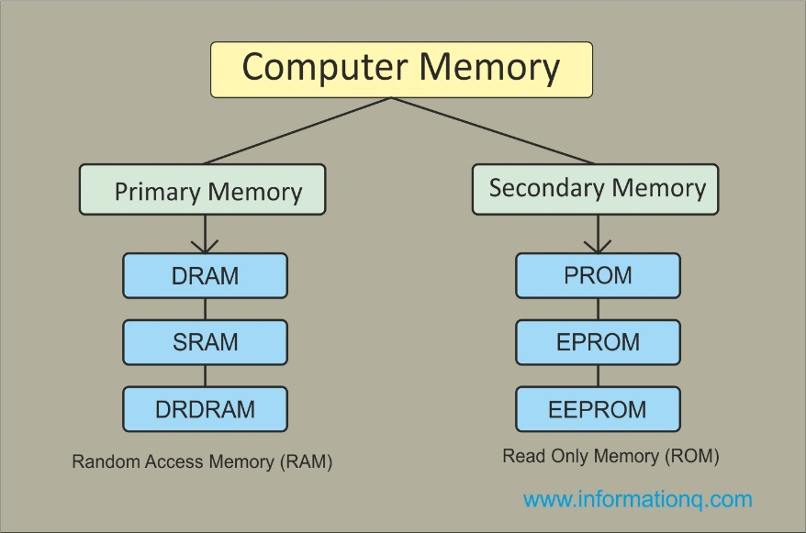

In [computing](https://en.wikipedia.org/wiki/Computing), a **memory module** or **RAM (**[**random-access memory**](https://en.wikipedia.org/wiki/Random-access_memory)**) stick** is a [printed circuit board](https://en.wikipedia.org/wiki/Printed_circuit_board) on which [memory](https://en.wikipedia.org/wiki/Computer_memory) [integrated circuits](https://en.wikipedia.org/wiki/Integrated_circuit) are mounted.[[1]](https://en.wikipedia.org/wiki/Memory_module#cite_note-1) Memory modules permit easy installation and replacement in electronic systems, especially computers such as [personal computers](https://en.wikipedia.org/wiki/Personal_computer), [workstations](https://en.wikipedia.org/wiki/Workstation), and [servers](https://en.wikipedia.org/wiki/Server_(computing)). The first memory modules were proprietary designs that were specific to a model of computer from a specific manufacturer. Later, memory modules were standardized by organizations such as [JEDEC](https://en.wikipedia.org/wiki/JEDEC) and could be used in any system designed to use them.

Types of memory module include:

* [TransFlash Memory Module](https://en.wikipedia.org/wiki/TransFlash_Memory_Module)
* [SIMM](https://en.wikipedia.org/wiki/SIMM), a single in-line memory module
* [DIMM](https://en.wikipedia.org/wiki/DIMM), dual in-line memory module
  + [Rambus](https://en.wikipedia.org/wiki/Rambus) memory modules are a subset of DIMMs, but are normally referred to as RIMMs
  + [SO-DIMM](https://en.wikipedia.org/wiki/SO-DIMM), small outline DIMM, a smaller version of the DIMM, used in laptops

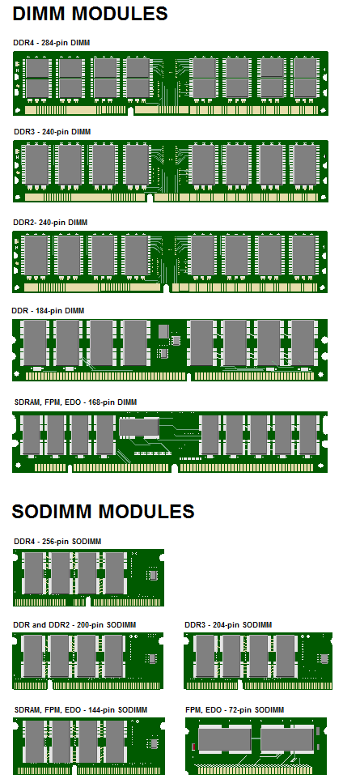

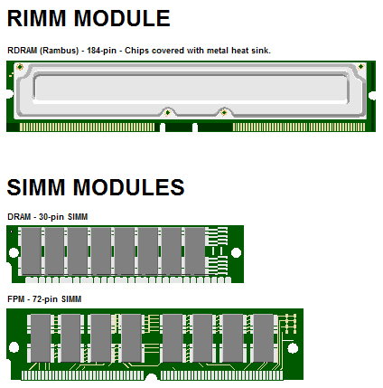

**DAUGTER CARD**

The daughter board is a computer hardware. It is also known as the piggyback board, riser card, daughter board, daughtercard or daughter card. A daughter board is a printed circuit board which is connected to the motherboard or expansion card. As compared to the motherboard, it is smaller in size. A daughter board does not act as an expansion card. An expansion card adds extra new functions to the computer. But a daughter board that is connected to the motherboard adds or supports the main functions of the motherboard.

Daughter boards are directly connected to the motherboards. You know that expansion cards are connected to the motherboard by using the bus and other serial interfaces.  But daughter board is directly connected to the board by soldering. As an update of the motherboard or expansion card, daughter boards are released to extend the features and services of the motherboard or expansion cards.

**Functionalities of a Daughter Board**

A daughter board is a circuit board that is directly connected to the motherboard or expansion card by soldering. Sometimes, people think that daughter board and expansion card are same. But this not true. They have their own functionalities. Daughter board’s functionalities are given below:

1. It is known as the piggyback board, riser card, daughtercard etcetera.
2. A daughter board is smaller than a motherboard and may have some slots like the motherboard.
3. A daughter board is a printed circuit board which is connected to the motherboard or expansion card.
4. Unlike expansion card, daughter boards are directly connected to the motherboard by soldering.
5. Daughter boards do not provide new functions to the circuit like an expansion But they extend the circuitry of the circuit in which they are plugged into.
6. Daughter boards are released by the vendors as an update of motherboard or expansion card.

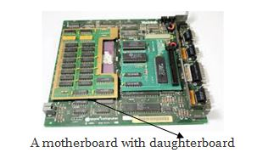

**BUS SLOT**

An expansion slot or bus slot is a socket on the motherboard that is used to insert an expansion card (or circuit board), which provides additional features to a computer such as video, sound, advanced graphics, Ethernet or memory.

The expansion card has an edge connector that fits precisely into the expansion slot as well as a row of contacts that is designed to establish an electrical connection between the motherboard and the electronics on the card, which are mostly integrated circuits. Depending on the form factor of the case and motherboard, a computer system generally can have anywhere from one to seven expansion slots. With a backplane system, up to 19 expansion cards can be installed.

Expansion cards can provide various functions including:

* Sound
* Modems
* Network
* Interface adapters
* TV and radio tuning
* Video processing
* Host adapting such as redundant array of independent disks or small computer system interface
* Solid-state drive
* Power-on self-test
* Advanced multirate codec
* Basic input/output system (BIOS)
* Expansion read-only memory (ROM)
* Security devices
* RAM memory

Older expansion cards also included memory expansion cards, clock/calendar cards, hard disk cards, compatibility cards for hardware emulation, and disk controller cards. The Altair 8800 was the first slot-type expansion card bus added to a microcomputer. It was developed in 1974-1975 by IBM Corp.

The expansion slot opening is generally located on the back of a PC and provides an electrical connection to the motherboard for an expansion card. Screws are then used to attach the card to the slot for added security.

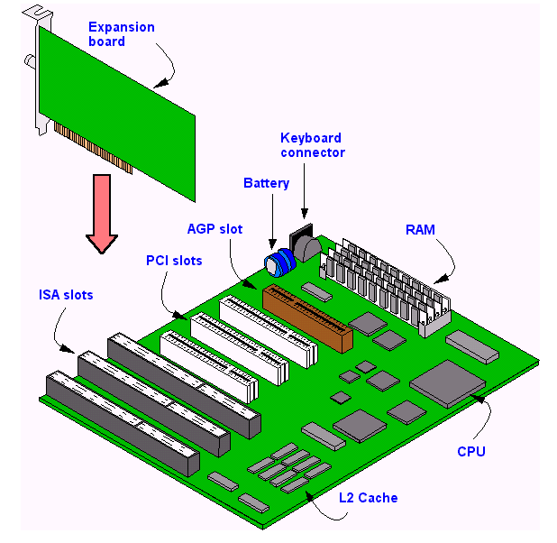

**SMPS (switched-mode power supply** )

A switched-mode power supply (SMPS) is an electronic circuit that converts power using switching devices that are turned on and off at high frequencies, and storage components such as inductors or capacitors to supply power when the switching device is in its non-conduction state.

Switching power supplies have high efficiency and are widely used in a variety of electronic equipment, including computers and other sensitive equipment requiring stable and efficient power supply.

A switched-mode power supply is also known as a switch-mode power supply or switching-mode power supply.

Switched-mode power supplies are classified according to the type of input and output voltages. The four major categories are:

* AC to DC
* DC to DC
* DC to AC
* AC to AC

A basic isolated AC to DC switched-mode power supply consists of:

* Input rectifier and filter
* Inverter consisting of switching devices such as MOSFETs
* Transformer
* Output rectifier and filter
* Feedback and control circuit

The input DC supply from a rectifier or battery is fed to the inverter where it is turned on and off at high frequencies of between 20 KHz and 200 KHz by the switching MOSFET or power transistors. The high-frequency voltage pulses from the inverter are fed to the transformer primary winding, and the secondary AC output is rectified and smoothed to produce the required DC voltages. A feedback circuit monitors the output voltage and instructs the control circuit to adjust the duty cycle to maintain the output at the desired level.

There are different circuit configurations known as topologies, each having unique characteristics, advantages and modes of operation, which determines how the input power is transferred to the output.

Most of the commonly used topologies such as flyback, push-pull, half bridge and full bridge, consist of a transformer to provide isolation, voltage scaling, and multiple output voltages. The non-isolated configurations do not have a transformer and the power conversion is provided by the inductive energy transfer.

Advantages of switched-mode power supplies:

* Higher efficiency of 68% to 90%
* Regulated and reliable outputs regardless of variations in input supply voltage
* Small size and lighter
* Flexible technology
* High power density

Disadvantages:

* Generates electromagnetic interference
* Complex circuit design
* Expensive compared to linear supplies

Switched-mode power supplies are used to power a wide variety of equipment such as computers, sensitive electronics, battery-operated devices and other equipment requiring high efficiency.

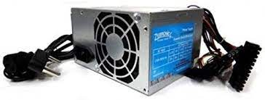

**Internal Storage Devices**

A storage device is a piece of hardware that is primarily used for storing data. Every desktop computer, laptop, tablet, and smartphone will have some kind of storage device within it. There are also standalone, external storage drives that can you can use across devices.

Storage is not only necessary for saving files, but also for running tasks and applications. Any file you create or save on your computer saves to your computer’s storage device. This storage device also stores any applications and your computer operating system.

As technology has advanced over time, data storage devices have also evolved in a major way. Nowadays, storage devices come in many shapes and sizes, and there are a few different types of storage device that cater to different devices and functions.

A storage device is also known as a storage medium or storage media. Digital storage is measured in megabytes (MB), gigabytes (GB), and, these days, [terabytes (TB)](https://www.dropbox.com/features/cloud-storage/how-much-is-1tb).

Some computer storage devices are able to hold information permanently while others can only hold information temporarily. Every computer has both primary and secondary storage, with primary storage acting as a computer’s short-term memory, and secondary as a computer’s long-term memory.

#### **Primary Storage: Random Access Memory (RAM)**

Random Access Memory, or RAM, is the primary storage of a computer.

When you’re working on a file on your computer, it will temporarily store data in your RAM. RAM allows you to perform everyday tasks like opening applications, loading webpages, editing a document or playing games. It also allows you to jump from one task to another without losing your progress. In essence, the larger the RAM of your computer, the smoother and quicker it is for you to multitask.

RAM is a volatile memory, meaning it cannot hold onto information once the system turns off. For example, if you copy a block of text, restart your computer, and then attempt to paste that block of text into a document, you’ll find that your computer has forgotten the copied text. This is because it was only stored temporarily in your RAM.

RAM makes it possible for a computer to access data in a random order, and thus reads and writes much faster than a computer’s secondary storage.

#### **Secondary Storage: Hard Disk Drives (HDD) & Solid-State Drives (SSD)**

In addition to RAM, every computer also has another storage drive that’s used for storing information on a long-term basis. This is secondary storage. Any file you create or download saves to the computer’s secondary storage. There are two types of storage device used as secondary storage in computers: HDD and SSD. While HDDs are the more traditional of the two, SSDs are fast overtaking HDD as the preferred tech for secondary storage.

Secondary storage devices are often removable, so you can replace or upgrade your computer’s storage, or move your storage drive to a different computer. There are notable exceptions, like MacBooks, which don’t offer removable storage.

#### **Hard Disk Drives (HDD)**

The hard disk drive (HDD) is the original hard drive. These are magnetic storage devices that have been around since the 1950s, though they’ve evolved over time.

A hard disk drive is comprised of a stack of spinning metal disks known as platters. Each spinning disk has trillions of tiny fragments that can be magnetized in order to represent bits (1s and 0s in binary code). An actuator arm with a read/write head scans the spinning platters and magnetizes fragments in order to write digital information onto the HDD, or detects magnetic charges to read information from it.

HDDs are used for TV recorders, servers, and laptop and PC storage.

#### **Solid-State Drives (SSD)**

Solid-state drives emerged far more recently, in the ‘90s. SSDs don’t rely on magnets and disks, instead they use a type of flash memory called NAND. In an SSD, semiconductors store information by changing the electrical current of circuits contained within the drive. This means that unlike HDDs, SSDs don’t require moving parts to operate.

Because of this, SSDs not only work faster and smoother than HDDs (HDDs take longer to gather information due to the mechanical nature of their platters and heads), they also generally last longer than HDDs (with so many intricate moving parts, HDDs are vulnerable to damage and wear).

Outside of newer PCs and high-end laptops, you can find SSDs in smartphones, tablets, and sometimes video cameras.

**Interfacing Ports**

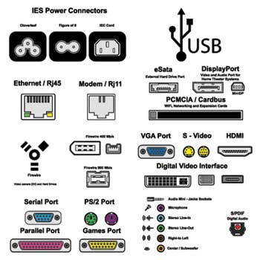

## **Serial Port**

* Used for external modems and older computer mouse
* Two versions: 9 pin, 25 pin model
* Data travels at 115 kilobits per second

## **Parallel Port**

* Used for scanners and printers
* Also called printer port
* 25 pin model
* IEEE 1284-compliant Centronics port

## **PS/2 Port**

* Used for old computer keyboard and mouse
* Also called mouse port
* Most of the old computers provide two PS/2 port, each for the mouse and keyboard
* IEEE 1284-compliant Centronics port

## **Universal Serial Bus (or USB) Port**

* It can connect all kinds of external USB devices such as external hard disk, printer, scanner, mouse, keyboard, etc.
* It was introduced in 1997.
* Most of the computers provide two USB ports as minimum.
* Data travels at 12 megabits per seconds.
* USB compliant devices can get power from a USB port.

## **VGA Port**

* Connects monitor to a computer's video card.
* It has 15 holes.
* Similar to the serial port connector. However, serial port connector has pins, VGA port has holes.

## **Power Connector**

* Three-pronged plug.
* Connects to the computer's power cable that plugs into a power bar or wall socket.

## **Firewire Port**

* Transfers large amount of data at very fast speed.
* Connects camcorders and video equipment to the computer.
* Data travels at 400 to 800 megabits per seconds.
* Invented by Apple.
* It has three variants: 4-Pin FireWire 400 connector, 6-Pin FireWire 400 connector, and 9-Pin FireWire 800 connector.

## **Modem Port**

* Connects a PC's modem to the telephone network.

## **Ethernet Port**

* Connects to a network and high speed Internet.
* Connects the network cable to a computer.
* This port resides on an Ethernet Card.
* Data travels at 10 megabits to 1000 megabits per seconds depending upon the network bandwidth.

## **Game Port**

* Connect a joystick to a PC
* Now replaced by USB

## **Digital Video Interface, DVI port**

* Connects Flat panel LCD monitor to the computer's high-end video graphic cards.
* Very popular among video card manufacturers.

## **Sockets**

* Sockets connect the microphone and speakers to the sound card of the computer.

**Server vs Desktop**

In general, a server could refer to a computer program running to satisfy requests from clients that are coming from the same machine or different computers in the network, or the physical computer that is actually running such a program. Simply, a server can be seen as a software service running on a dedicated computer and the service can be obtained by other computers in the network. A desktop is a personal computer that is intended for personal use at a single location and is considered to be not portable as laptops or other portable computers.

**Server**

A server is a software service running on a dedicated computer and the service provided by this can be obtained by other computers in the network. Sometimes the physical computer that runs this service is also referred to as the server. Mainly servers provide a dedicated functionality such as web servers serving web pages, print servers providing printing functionalities, and database servers providing database functionalities including storage and management of data. Even though a personal computer or a laptop can work as a server, a dedicated server contains special features that would allow it to efficiently satisfy incoming requests. Therefore, dedicated servers normally include faster CPUs, large high performing RAM (Random Access Memory) and large storage devices such as multiple hard drives. Furthermore, servers use operating systems (OS) that are server oriented

providing special features suitable for the server environments. In these OS, GUI is an optional feature and provides advanced back up facilities and tight system security features.

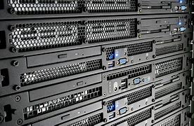

**Desktop**

A desktop is a computer intended for personal use and it is typically kept in a single place. Furthermore, desktop refers to a computer that is laid horizontally on the desk unlike towers. Early desktop computers were very large and they took up the space in a whole room. It was only in 1970s the first computers that could be kept on desk arrived. Widely used OS today in desktops are Windows, Mac OS X, and Linux. While Windows and Linux could be used with any desktop, Mac OS X has some restrictions. Desktops are powered from a wall socket and therefore power consumption is not a critical issue. Furthermore, desktop computers provide more space for heat dissipation

. Initially, desktop computers were not integrated with wireless technologies such as WiFi, Bluetooth and 3G, but currently they are integrated with wireless technologies.

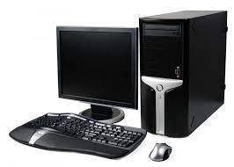

**Difference between a Server and a Desktop**

A desktop is a personal computer intended for personal use, while server is a dedicated computer that runs a software service that can be obtained by other computers in the network. Servers are normally made up of powerful components such as faster CPUs, high performing RAM and larger hard disks than desktop computers, since it needs to satisfy large number request at a given time. Furthermore, servers contain special server oriented OS that is capable of maintaining backups and providing improved security while the OS contained in desktop normally do not offer or offer simple versions of these services.

## **MAIN DIFFERENCES BETWEEN A DESKTOP AND SERVER**

Many people mistakenly believe that a [server](https://www.webopedia.com/definitions/server/) is no different from a typical [desktop computer](https://www.webopedia.com/definitions/desktop-computer/). This couldn’t be further from the truth. While almost any computer that meets the minimum hardware requirements can run a server operating system that alone does not make a desktop computer a true server. Even if the desktop computer had similar processor speeds, memory and storage capacity compared to a server, it still isn’t a replacement for a real server. The technologies behind them are engineered for different purposes.

A [desktop computer](https://www.webopedia.com/definitions/desktop-computer/) system typically runs a user-friendly operating system and desktop applications to facilitate desktop-oriented tasks. In contrast, a [server](https://www.webopedia.com/definitions/server/) manages all network resources. Servers are often [dedicated](https://www.webopedia.com/definitions/dedicated/) (meaning it performs no other task besides server tasks). Because a server is engineered to manage, store, send and process data 24-hours a day it has to be more reliable than a desktop computer and offers a variety of features and hardware not typically used in the average desktop computer.

## **SERVER HARDWARE**

One of the best choices for a small business is a [dedicated server](https://www.webopedia.com/definitions/dedicated-server/) built from the ground up as a file server to provide features and expansion options that a [desktop computer](https://www.webopedia.com/definitions/desktop-computer/) lacks. Some server hardware decisions you will need to make include the following:

1. [**Form Factor**](https://www.webopedia.com/definitions/form-factor/)**:** For small businesses, the best choice is a dedicated entry-level server in a tower configuration.
2. [**Processor**](https://www.webopedia.com/definitions/microprocessor/)**:**Choose a server-specific processor to boost performance and data throughput.
3. [**Memory**](https://www.webopedia.com/definitions/memory/)**:** Buy as much memory as you can afford and look for expansion slots for future upgrades.
4. [**Storage**](https://www.webopedia.com/definitions/mass-storage/)**:** Look for SATA or SCSI hard disks, not IDE.

## **SERVER OPERATING SYSTEM**

The [operating system](https://www.webopedia.com/definitions/operating-system/) (OS) is the software platform on top of which other programs will run. Choosing a server operating system is no easy task. The specific operating system you go with will depend on what the server is going to be mainly used for. For basic file servers a small business should choose an operating system that staff will be the most comfortable with. Another issue to consider is if you have any application that is best-suited to a particular operating system.

## **ADDITIONAL SERVER CONSIDERATIONS**

For the average home user looking for a basic, infrequently used server a built from an old [desktop computer](https://www.webopedia.com/definitions/desktop-computer/) could work. For the small business owner, however, the question to ask is: Do you really want to trust your business data and processes to just any old hardware? Most small businesses will be far happier with a computer that is ready-made to be a [dedicated server](https://www.webopedia.com/definitions/dedicated-server/) than with one that began life as a standard desktop computer. If your company’s data is at all important to you, it is the only way to go.

**Choosing the Right Server**: Before investing in server hardware, you need to consider applications, storage, processor, form factor, and more to help you choose wisely.

**Installation of common os and server use**

• Determining Which Operating System to Install

• Decide whether to purchase or download. Windows licenses need to be purchased. Each license comes with a key good for one installation. Most Linux distributions are free to download and install as much as you'd like, though

• Research your software compatibility. Make sure that the operating system you want to install supports the programs that you want to use. If you use Microsoft Office for work, you won't be able to install it on a Linux machine. There are substitute programs available, but the functionality may be limited.

• Obtain your new operating system. If you've purchased a copy of Windows from a store, you should have received an installation disc along with your product code. If you don't have the disc but have a valid code, you can download a copy of the disc online. If you are installing Linux, you can download an ISO of the distribution from the developer's website.

• An ISO file is a disc image that needs to be burned to a disc or copied to a bootable USB drive

• Backup your data. When you are installing a new operating system, you are most likely going to be wiping the hard drive in the process. This means that you will lose all of your files on the computer unless you back them up. Always make sure that any important files are copied to a backup location before starting the installation process. Use an external hard drive or burn the data to DVDs.

• If you are installing the operating system alongside your existing one, you most likely will not have to delete any data. It is still wise to backup important files just in case.

• You cannot backup programs; they will need to be reinstalled once you have finished installing your new operating system

• Enter your product key. If you are installing Windows 8, you will need to enter your product key before you can begin the installation. Older Windows versions will ask for the product key after installation is complete. Linux users will not need a product key unless it is a purchased version such as Red Hat.

Choose your installation type. Windows will give you the option of Upgrading or performing a Custom installation. Even if you are upgrading an older version of Windows, it is highly recommended that you choose Custom and start from scratch. This will minimize problems that may arise later from combining old settings and new ones.

• If you are installing Linux, you will be given the option to install alongside your existing operating system (Windows), or to erase the disk and install Linux by itself. Choose the option that best meets your needs. If you choose to install alongside Windows, you will be given the option to choose how much hard disk space you want to designate for Linux.